Realization of Mechanical Properties Prediction from Nano- to Macro- scale Structure: an Achievement of C-S-H Hydrated Phases
Jia Fu^{1,2, a*}
¹School of Material Science and Engineering, Xi'an Shiyou University, Xi'an, 710065, China
²Laboratoire de Génie Mécanique, Institut National des Sciences Appliquées de Rennes, Rennes 35708, France
ªfujia@xsyu.edu.cn
Keywords: C-S-H structure, Nano-scale, Molecular dynamics, Nano-indentation, Mechanical properties
Abstract. The performance prediction of C-S-H gel is critical to the theoretical research of cement-based materials. In the light of recent computational material technology, modeling from nano-scale to micro-scale to predict mechanical properties of structure has become research hotspots. This paper aims to find the inter-linkages between the monolithic "glouble" C-S-H at nano-scale and the low/high density C-S-H at the micro-scale by step to step method, and to find a reliable experimental verification method. Above all, the basic structure of tobermorite and the "glouble" C-S-H model at nano-scale are discussed. At this scale, a monolithic C-S-H structure of about 5.5 nm3 was established based on the 11Å tobermorite crystal, and the elastic modulus ​​of the isotropic "glouble" is obtained by simulation. Besides, by considering the effect of porosity on the low/high density of the gel morphology, the C-S-H phase at micro-scale can be reversely characterized by the "glouble". By setting different porosities and using Self-Consistent and Mori-Tanaka schemes, elastic moduli of the low density (LD) and high density (HD) C-S-H from that of "glouble" are predicted, which are used to compare with the experimental values of the outer and inner C-S-H. Moreover, the nanoindentation simulation is carried out, where the simulated P-h curve is in good agreement with the accurate experimental curve in nanoindentation experiment by the regional indentation technique(RET), thus the rationality of the "glouble" structure modeled is verified and the feasibility of Jennings model is proved. Finally, the studies from the obtained ideal "glouble" model to the C-S-H phase performance has realized the mechanical properties prediction of the C-S-H structure from nano-scale to micro-scale, which has great theoretical significance for the C-S-H structural strengthening research.
Introduction
With the development of computational material technology, material structure from nano-to macro-scale cause great concern for scholars^{[1,2]}. Size-dependent morphology can link the nano to the macro scale^{[3]}, thus can be extend to building material design to attain unexplored properties^{[4]}. For concrete composite material, the identification of the material properties in nanostructures has been investigated ^{[5]}.
Calcium Silicates Hydrates (C-S-H) is the most important binding phase in cement paste. C-S-H gel is composed of monolithic C-S-H (full dense C-S-H) and porosity^{[6]}. A nano-scale, C-S-H gel has two forms of Low Density C-S-H and High Density C-S-H by Jennings ^{[7]}. The mechanical properties of the amorphous layered C-S-H ^{[8]} is about 67 GPa. For the elastic modulus of C-S-H, Constantinides et al. ^{[9]} has determined elastic moduli of LD C-S-H 21.7 GPa and HD C-S-H 29.4 GPa by nanoindentation experiment. However, the full structural C-S-H information (atoms and their positions) from the macro-scale by the neutral scattering tests to nano-scale by the amorphous C-S-H cell is unknown.
As the relationship between the C-S-H structure of about 5.5nm as the "glouble" form and C-S-H phases (LD and HD C-S-H) has not been revealed yet. Our aim is to find the relation between the possible amorphous C-S-H nanostructure in simulation and microscale C-S-H phases in experiment, where the "glouble" C-S-H is a link with considering the porosity to reveal the different densities.
In this study, the process during structure parameterization, approximations in theoretical 11 Å tobermorite model, structural characterization of "glouble" C-S-H and verification of elastic moduli in nano-indentation experiment, is addressed, which is meaning for both the molecular simulation and nano- indentation experiment. Based on the previous studies, the mechanical properties prediction of C-S-H structures from nano- to macro-scale structure can be realized step by step, thus the simulated structure and the experimental structure have been unified.
Description of C-S-H phase modeled at nanoscale
According to the reference of Richardson^{[10]} and Jennings^{[7]}, two C-S-H structures at nano-scale are in Fig.1.
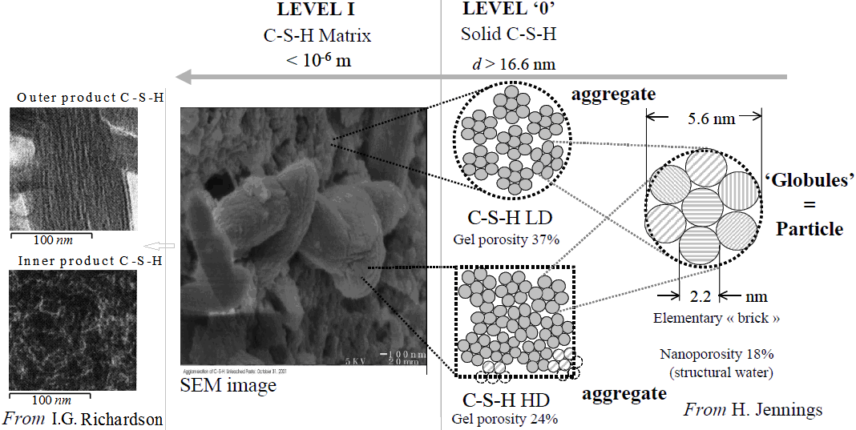
Fig.1 Two typical C-S-H structures at nanoscale ^{[7]}
From Fig.1, the inner and outer C-S-H phases can be modeled with the gel porosity of solid phase LD C-S-H 35-37% and HD C-S-H 24%, separately.
Crystalline C-S-H modeled by tobermorite. Commonly, the 11Å tobermorite[11] monoclinic crystal with ordered Si chains at long-range is found to establish the C-S-H model in most case, in Fig.2.
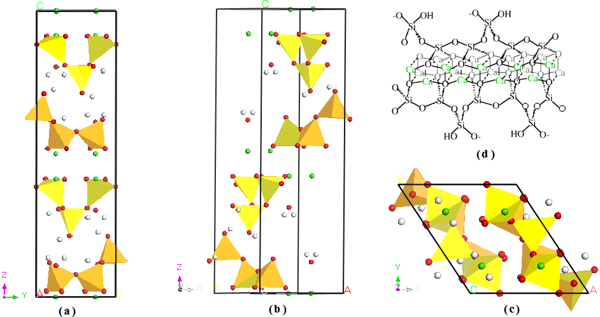
a) In x-direction; b) y-direction; c) z-direction; d) Si chain
(Silicate chains, calcium octahedral, and oxygen atoms are dark blue, light blue tetrahedra, and red spheres.)
Fig. 2 Modeling of 11 Å tobermorite crystal
In Fig.2 a-c, the 11Å tobermorite structure can be described as follows: (1) the monoclinic crystal belongs to a kind of layered structure. (2) on both sides, silicate chains surround the Ca–O sheet (in Fig.2 a). (3) between individual layers, Ca²⁺ and H₂O are filled so as to balance the charges. In Fig.2 c), the infinite layers of calcium polyhedra is normally parallel to (001), and the tetrahedral chains ……………………………… …
Hamid has proposed structure of 11Å tobermorite with three Ca/Si ratios ^{[15]}, in Fig.3.
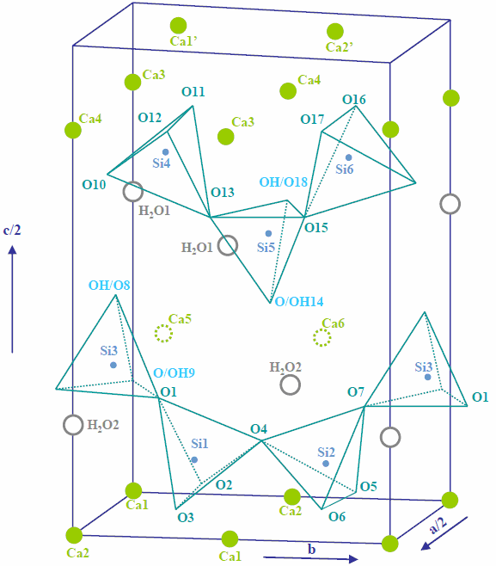
Fig.3 A three dimensional view of tobermorite ^{[15]}
It can be seen in Fig. 3 that, for the system of Ca/Si of 0.66, 0.83 and 1.0, with a number of the protonated sites four, two and none, where the structures are separately lack of Ca₅+Ca₆ atoms, Ca₆ atom and no change. Thus the Ca/Si can be changed by the addition of Ca atom in this way or removel of silicate tetrahedral in [010] to meet the targeted parameters of Ca/Si ratio and Qn distribution, detailed in reference^{[16]}. The Ca/Si ratio of C-S-H phase is about 1.7 ^{[17]} with the Q_{n} distribution of Q₀≈10%, Q₁≈67% and Q₂≈23% [¹⁸].
. …………………………………………………………………………………………………………
Simulation and assessment of LD/HD C-S-H
Simulation details by MD method. The ClayFF field ^{[21]} and Lammps package code ^{[22]} is used in molecular simulation. Besides, Coulomb interaction of Eward truncation ……………………………… …
Results and discussions of "gouble" C-S-H. Using molecular dynamics, the elastic properties of the “globule” C-S-H nano-structure is calculated by the averaged slope of strain-stress curves simulated. In three loading directions, strain-stress curves of "glouble" C-S-H under three directions ………………………………………………………………………
Assessment of LD/HD C-S-H moduli. At the upper-scale, the "glouble" C-S-H structure about 5.5 nm can be used to assess elastic modulus of LD C-S-H and HD C-S-H using Self-Consistent and Mori-Tanaka schemes assuming a certain porosity^{[23]}.
A self-consistent scheme may be used Eq. 1 and Eq. 2^{[24]}:
. (1)
. (2)
Where ; g_{s} is shear modulus of the full-dense C-S-H (here g_{s}= E_{s}/[2(1+μ_{s})]); k_{s} is bulk modulus of the full-dense C-S-H (here k_{s}= E_{s}/[3(1-2μ_{s})]); φ_{s} is the porosity. The usage of E_{s}=60.95GPa, μ_{s}=0.25 and r_{s}=1.67 for "glouble" C-S-H found in this work. using the Self-Consistent Scheme in the Eq.(1)-(2), LD and HD C-S-H are assessed to be 18.11 GPa and 31.45 GPa, with the porosity of 35% and 24% for LD C-S-H and HD C-S-H, separately.……………………………………………
Verification of nano-indentation experiment

Nano-indentation tester and sample paste. ………………………………………………………………………

Nano-indentation experiment and analysis. ……………………………………………………………………… is in Table 1.
Table 1 The austenite transformation of the 23CrNi3Mo steel (without carburization treatment) during the isothermal process at various soaking temperatures
Soaking temperature (ºC) | 375 | 400 | 425 | 450
Incubation time (s) | 25 | 46 | 56 | 62
Start time (s) | 25 | 46 | 56 | 62
Finish time (s) | 1143 | 1638 | 1719 | 2957

The E_{HIT} analysis of cement phases by nano-indentation experiment. The evolution of the elastic modulus E_{HIT} (unit: GPa) and maximum depth h_{max} (unit: nm) as a function of the indented position of the untreated sample are recorded. ……………………………… ………………………………………………………………………
Conclusion
For the "glouble" C-S-H structure (the formula: (CaO)1.67(SiO2)(H2O)1.75), the nanoscale structure during the stretch process using ClayFF field is simulated and then the elastic modulus is calculated. Therefore, the assessment elastic moduli of LD and HD C-S-H is determined with considering the porosity. Nano-indentation experiment is done to find the elastic modulus values of inner and outer C-S-H to compare with results obtained by using simulation and calculation. Results are as follows:
(1) The averaged modulus in x, y and z-directions is rather the same, about 60.95 GPa under strain rate of 10-3 ps-1 at 300 K, ………………………………… ……………………………… …………………………………
Acknowledgments. The authors acknowledge the financial support provided by China Scholarship Council and support of start-up foundation of Xi’an Shiyou University. Thanks to prof. Fabrice Bernard and Siham Kamali-Bernard for their help and also Qiufeng Wang for her proofreading. The authors are grateful for technical support and the assistance in EDS analysis of the CMEBA facility (ScanMAT, University of Rennes 1).
References
[1] L.L. Graham-Brady ,S.R. Arwade ,D.J. Corr , et al, Probability and materials: from nano-to macro-scale: a summary,Probabilist. Eng. Mech. 21(2006)193-195.
[2] J. van der Geer, J.A.J. Hanraads, R.A. Lupton, The art of writing a scientific article, J. Sci. Commun. 163 (2000) 51-59.
[3] W. Strunk Jr., E.B. White, The Elements of Style, third ed., Macmillan, New York, 1979.
[4] G.R. Mettam, L.B. Adams, How to prepare an electronic version of your article, in: B.S. Jones, R.Z. Smith (Eds.), Introduction to the Electronic Age, E-Publishing Inc., New York, 1999, pp. 281-304.
[5] R.J. Ong, J.T. Dawley and P.G. Clem: submitted to Journal of Materials Research (2003)
[6] P.G. Clem, M. Rodriguez, J.A. Voigt and C.S. Ashley, U.S. Patent 6,231,666. (2001)
[7] Information on http://www.weld.labs.gov.cn

